SVFSC Board Meeting
March 16, 2025
6:30
Minutes
Officers Present: Erica Olson-President, Melissa Snyder-Vice President, Brittany Myszka-Treasurer, Paula Betz-Secretary
Board Members Present: Rachelle Klein, Andy Schillinger, Amanda Crouse, Will Berger
Others Present: Heather Awender, Kayla Hammond, Katie Rauber, Bethany Rausch, Cortney Mann, Madison Yaggie-Schuler
Approve Agenda: Motion to approve agenda as presented by Andy, 2nd by Will.
Motion passed.
Treasurer’s Report: Brittany
- Club Account- $58,584.80
- Trust Account- $11,439.99
- Gaming Account- $281,026.35
- Money Market Trust- $47, 720.07
- CD- $150,000
- Motion to approve Treasurer’s Report by Melissa and 2nd by Andy. Motion Passed.
Old Business
- Club room furniture will be ordered after the show is over. Melissa and Rachelle will work on this.
- Bylaws Review – suggested changes were reviewed by the board and will be approved at the April meeting.
  - Suggestions to the bylaws are attached to the minutes.
  - Erica will send to club lawyer to ensure any possible changes are legal.
- Spring Banquet-April 27 at the Wahpeton Community Center 1-3
  - Melissa, Erica, Amanda, Heather and Kayla will plan
- Harness Update-Andy and Ben spoke with Gast construction about the harness installation -approximate cost of $20,000.
Motion by Will for Andy to keep moving forward with harness proposal and 2nd by Amanda. Approved.
Andy will update the board once he has an official proposal from Gast and this will be discussed at Head of the Red.
- Software options for checking skaters on and off the ice -Melissa visited with Digital Guru and will get back to the board once options and prices are available.
New Business
- Board members terms/elections-Paula and Amanda mentioned they will not be running for a second term when theirs is up on June 30. There will be two open board seats and elections will be held at the annual meeting on April 27.
- April/May Ice-
  - April 2-May 4th-Tues. 6-9 p.m., Fri. 6-8 a.m.,
And Sun. 4:30-7:30 p.m.- $8/hour and punch cards are still valid.
Contract is $3900 for April Ice.
  - 4-Half hour Learn To Skate Lessons (all levels) will be offered for $50 for the session and will be at 6:00 p.m. on Tuesdays. First open it to SVFSC skaters and then to Fergus skaters if there are spots open.
Motion by Amanda to approve April Ice @$3900 and to have Learn to Skate Classes at 6:00 p.m. on Tuesdays. 2nd by Rachelle. Approved.
- Summer Ice Possibilities- A survey will be taken to see if there is interest in Fergus Falls Ice and what time of day works for skaters. The cost for ice in Fergus Falls in the summer is $195/hour and will run for a total of 6 weeks. If SVFSC chooses to purchase ice, the cost would likely be $15-20 per hour, so higher than our regular season rate, due to the higher rental cost.
- Head of the Red update-Kayla-Ice will be $82/hour for the 2025/2026 season. Total of around $30,073.50. Sunday times might change to 1:30 to 5:45. Contract for 26-27 not signed, Kayla not ok with the $110 per hour that we would be charged for non-premium ice. Will revisit next year with Head of the Red.
- Spring Show
  - Digital Tickets-are available now-you need to set up an acct. to order. They will only be available until the Friday before the show.
  - Venmo and cash will be accepted at the door.
  - Coach Compensation-payment will be the week after the show.
  - Melissa organized meals for advanced skaters on March 13, 19, 20, 26. Cost will be $5 per skater.
  - Photos are March 22-probably won’t be on a Saturday next year.
  - KBMW advertising-$300 for 5 ads per day.
    - Radio ads to run for two weeks before the show.
    - Live interview March 28 at 8:05 a.m.
  - Skater good luck messages will be put off until Leap and Compete
  - Amanda will print the program
  - Comp tickets for sponsors and 2 for attached sponsor list
    - Sponsors
      - $50-$99 1 ticket for Sat. or Sun. Show
      - $100-$199 2 tickets for Sat. or Sun. Show
      - $200-$299 4 tickets for Sat. or Sun. Show
      - $300 and up 8 tickets for Sat. or Sun. Show
    - All volunteers get in free
  - Skaters need to make sure they have hard guards and skating tights for the show.
  - Heather to create Facebook Event
- Announcer for club events-if we hire someone we need to have them bring the whole sound system also. No need to hire anyone for this year’s show.
- Committee Updates
  - Leap and Compete- February 22
    - Was a big success! Lots of compliments from skaters, coaches and clubs
    - Suggestions for next year
      - How to secure arena the night before competition
      - Need volunteers in the morning of competition
      - Flower sales were low, as well as dress sale participation
      - Venmo was appreciated for concessions
      - Curling iron/straightener use in locker rooms-need to remind people not to use!
      - Concessions went well
      - Colored wrist bands for locker rooms may not be needed
      - Awards-make sure medals for each group are rubber banded together or put in zip lock bags
  - SafeSkate-all board members must be certified and current
- National Showcase Event-Tessa Snyder qualified. Coach that attends with Tessa will be reimbursed according to competition payment and per diem per contract.
- Closed board session
  - Motion made by Will to put $20 Chamber Bucks in each of the coaches Thank You Cards. 2nd by Andy. Approved. Also for Ben

Adjourn

Future meeting dates: April 13, 2024
April 27, 2025- General Membership Meeting and Banquet

Sponsor Complimentary Ice Show Tickets
Sponsor | Level | Tickets | Receipt Made | Donation $
Lions | - | 0 | x | 25
Bell Bank | Bronze | 1 | x | 50
Summerville Electric | Bronze | 1 | x | 50
Kiwanis | Gold | 4 | x | 200
Smith Motors | gold | 4 | x | 200
Ace | in kind | 2 | 0 | 0
AgCountry | in kind | 2 | 0 | 0
Dean Twidwell - Wahp Deli | in kind | 2 | 0 | 0
Driftwood | in kind | 2 | 0 | 0
Lovin Nutrition | in kind | 2 | 0 | 0
Shanna Casey | in kind | 2 | 0 | 0
Zoo | in kind | 2 | 0 | 0
Kelly Smith | in kind | 8 | 0 | 0
Breck Fire | Platinum | 8 | x | 300
Fairmount Fire | Platinum | 8 | x | 300
MKAP | Platinum | 8 | x | 300
Bremer Bank | Silver | 2 | x | 100
Fort Saloon | Silver | 2 | x | 100
Miller Realty | Silver | 2 | x | 100
OK Tire | Silver | 2 | x | 100
RRVW | Silver | 2 | x | 100

Board discussed changes to bylaws. Vote on any changes will be at April meeting. Discussion on by laws continues.
BYLAWS
OF
SOUTHERN VALLEY FIGURE SKATING CLUB INC.

ARTICLE I
NAME

The name of the organization shall be Southern Valley Figure Skating Club Inc. (hereinafter known as “the Club”) and it shall operate for one or more of the exempt purposes set forth in Section 501(c)(3) of the Internal Revenue Code.

This Club shall have its headquarters in the Ella Stern & Harry Stern Sports Arena 1026 11th Street North, Wahpeton, ND 58075. The mailing address of the club shall be PO Box 1412 Wahpeton, ND 58074.

ARCTICLE II
PURPOSE AND OBJECTIVES

The purpose of the Club is any lawful purpose, subject to the provisions regarding exempt organizations contained in section 501(c)(3) of the Internal Revenue Code.

In general, however, the Club will seek to further the following objectives:

The principal purpose of the Club is to encourage the instruction, practice and advancement of all types of ice skating; to encourage and cultivate a spirit of goodwill among ice skaters; to produce and cooperate in the production of ice shows; to do and perform such other acts as may be necessary, advisable, proper or incidental in the realization of the objects and purposes of this Club; and to carry out the general policies of the United State Figure Skating Association (USFSA) and the Learn To Skate program, regardless of age, race, sex, creed, color, national origin or ancestry.

ARCTICLE III
MEMBERSHIP

SVFSC club membership consists of the following individuals:
- Parents and guardians of skaters with an active registered SVFSC skater.
- Registered SVFSC skaters aged 18 and over.
- Any current coach or contractor whose home club is SVFSC.

Registered members of the Club shall also be members of the United States Figure Skating Association. The Board of Directors shall have the authority to assess annual membership dues. Any member in arrears shall be notified by mail by the treasurer or designated person. No member in arrears shall be eligible to serve on the Board of Directors, take part in club activities or be entitled to vote.

ARCTICLE IV
BOARD OF DIRECTORS

The Board of Directors shall be the governing body of the Club. It shall administer all funds and shall manage the affairs of the Club. The Board of Directors shall consist of nine members with a minimum of seven.

Election of the Board of Directors shall be determined by majority vote of club membership at the annual meeting. The exception is the inaugural year, where the Board of Directors are the founding members.

The Directors shall be for a term of two years, with no more than two consecutive terms served, unless they serve as an Officer, then the terms for Officer positions apply (see below). Former Directors may re-join after a period of one year’s absence from the board, provided a vacancy is available.

At the discretion of the Board, a member may be removed from the Board of Directors by vote of the Board for missing three consecutive meetings. A Board member may also be removed for lack of participation in meetings and/or club events. Any vacant positions will be appointed by the Executive Board to fill the remainder of the fiscal year and appointee is still eligible to serve two additional consecutive terms, if elected.

All members of the Board of Directors shall deliver to their successors, immediately upon relinquishing office, all records, correspondence, and other properties belonging to the Club.

The Board of Directors shall have the authority to appoint committees consistent with the purpose of this organization. Committee membership is open to all club members. Current and past board members are encouraged to serve on committees.

ARCTICLE V
BOARD ELIGIBILITY AND CONFLICT OF INTEREST

SVFSC board members must meet the qualifications of membership as stated in article III.
Active club members are eligible to be on the board of directors with the following exceptions;
- Board members shall not consist of immediate family members or live in the same household. The IRS typically considers grandparents, spouses, or siblings a relationship. Any relationship beyond an immediate family member, such as a cousin or aunt, is not normally considered a relationship for conflict purposes.
- Any contractor of the SVFSC may not serve on the board of directors due to conflict of interest
- Any member who is not in good financial standing with the club cannot serve on the board of directors.
Board members should receive no monetary compensation for their board duties other than reimbursement for board-related expenses and reasonable compensation for services provided by a board member. SVFSC may pay reasonable compensation for services provided by officers and staff.
A conflict of interest is created if the SVFSC chooses to use services provided by a board member’s for-profit company. If SVFSC wants to use such services, services must be provided at a fair market value. Board members who’s for profit services are being provided must sit out on any voting that pertains to such services.
ARCTICLE VI
EXECUTIVE BOARD OF OFFICERS

The Executive Board of Officers shall be elected by majority vote of the Board of Directors through use of a written ballot, prior to the general membership election. One year of service is recommended prior to seeking an officer position.

In the event that the President vacates his/her position, the Vice President shall step-up to fill the vacancy and a new Vice President will be voted into that position. In the event of the treasurer or secretary vacating their position, the Board of Directors shall act swiftly to appoint or vote another Board member to fill the position.
Fulfilling remainder of vacancy position does not apply to officer term limits.

A board member may serve two full officer terms for up to two consecutive officer roles then serve a mentor year and then take a year absence from the board. Former Officers may re-join after a period of one year’s absence from the board, provided a vacancy is available

Terms and duties of Officers:
- President
- Eligibility- Previously served as an officer of the Board of Directors
- Term - one year, followed by one additional year on the Standard Board of Directors as mentor
- Term Limit- May be elected to fill two full consecutive terms
- Duties - Take charge of the Club, preside at all meetings of the Club and of the Board of Directors, execute the power to suspend any member for violating the bylaws, to call special meetings and club meetings, sign all agreements made by the Club (upon approval of the Board of Directors), club generated contracts will be signed by the president and one other officer.
- Vice President
- Term - one year
- Term Limit- May be elected to fill of two full consecutive terms
- Duties – Assist the President, act on behalf of the President in his/her absence

- Treasurer
- Term – one year, followed by one additional year on the standard Board of Directors as mentor
- Term Limit- May be elected to fill two full consecutive terms
- Duties, with coordination of SVFSC bookkeeper – have charge of the funds of the Club, keep record of all receipts and disbursements, deposit funds in the bank approved by the Board of Directors, obtain any cash needed for Club events, submit a written report at each meeting of the Board of Directors, prepare a fiscal year-end report, coordinate income tax preparation by the accountant approved by the Board of Directors

- Secretary
- Term – one year
- Term Limit- May be elected to fill two full consecutive terms
- Duties – keep minutes of the Club meetings and Board of Directors, supervise correspondence of the club, prepare and issue notices of all meetings of the Club and Board of Directors

ARCTICLE VII
MEETINGS

The Club Board of Directors shall meet no less than semi-annually. Regular meetings shall be held at the call of the President or other duly constituted authority of the Club. A special meeting of the Club may be called at any time by the President or by any member of the Board of Directors. A majority of the Board shall constitute a quorum. Every effort will be made to attend meetings in person. However, any or all board members may attend board meetings virtually. A member actively participating in a virtual meeting is deemed to be present. A written record of all meetings of the Board of Directors and the Club shall be maintained by the Secretary. The presiding Executive Board has the discretion to close the meeting to the public, unless previously voted on by the full board. This shall include any contract negotiations between the Executive Board and the coaches.

There shall be one annual Club membership meeting each year. The annual meeting shall be held in the spring. Any current club member as defined in article VI is eligible to participate and vote on any matters at the annual meeting.

The rules contained in Robert’s Rules of Order Revised shall govern all proceedings of the Club, the Board of Directors, and any committees.

ARTICLE VIII
FUNDS AND LIABILITY

Initial funds for the activities of the Club shall come from an endowment through a testamentary gift made from the estate of the donor. All funds accrued by the Club shall be deposited to the account of the Club and shall be dispersed by the Treasurer or designated member of the Club as authorized by the Board of Directors. The fiscal year shall align with the standard set by the United States Figure Skating Association, beginning on July 1 and ending on June 30.

ARTICLE IX
CONFLICT RESOLUTION

If any member of the Club has a complaint against another member of the Club, a Board Director, a Board Officer, or agent of the club for an infraction of any Bylaw, rule, policy or procedure of the Club, other than U.S. Figure Skating Rules, they may file a complaint in writing to the Board of Directors of the Club. Such complaints will be investigated and resolved according to the Club's conflict resolution policy that the Club is required to adopt and have in effect in accordance with the Bylaws of U.S. Figure Skating.

ARTICLE X
AMENDMENTS

Amendments to these Bylaws or the Articles of Incorporation may be made at any meeting of the Board of Directors but shall require consent by majority (5) Board Members.

ARTICLE XI
ACTIVITIES AND DISSOLUTION

This organization is organized exclusively for one or more of the following purposes: charitable, religious, educational, scientific, literary, fostering national or international sports competition, preventing cruelty to children or animals, and testing for public safety purposes, within the meaning of Section 501(c)(3) of the Internal Revenue Code. No part of the net earnings shall inure to the benefit of the Members or Board of Directors (except that reasonable compensation may be paid for services rendered to or for the Association). Upon dissolution, assets will be distributed to the Head of the Red Youth Activities Association. Head of the Red Youth Activities Association is unable, unwilling, or ineligible to receive the assets, the assets shall be distributed to the City of Wahpeton or the State of North Dakota for a public purpose or to an organization exempt under section 501(c)(3) of the Internal Revenue Code.

Duly adopted by the Board of Directors on the 29th day of October 2017.
Amended and adopted by the Board of Directors on the 14th day of August 2022. on the 11th day of June 2023, and on the 9th day of June 2024.
Southern Valley Figure Skating Club Inc.
Brittany Myszka; Secretary
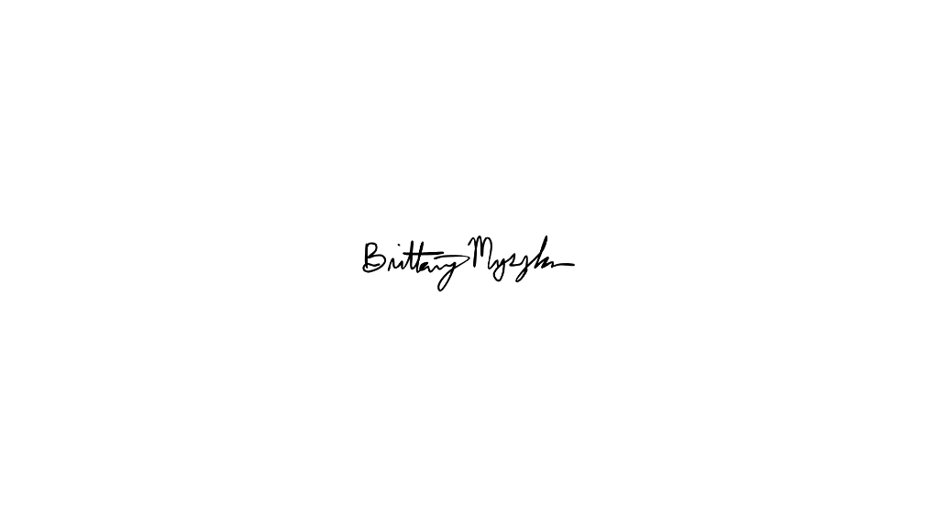
____________________________
Signature
6/24/24
_____________________________
Date

